TASK 3
#include <iostream>
#include <ctime>
using namespace std;

void PrintArray(int arr[], int n) {
for (int i = 0; i < n; i++) {
cout << arr[i] << " ";
}
cout << endl;
}

void bubbleSort(int arr[], int n) {
int comparisons = 0;
for (int i = 0; i < n - 1; i++) {
for (int j = 0; j < n - 1; j++) {
comparisons++;
if (arr[j] > arr[j + 1]) {
swap(arr[j], arr[j + 1]);
}
}
}
cout << "\nNumber of comparisons: " << comparisons << endl;
cout << "Sorted array (Bubble Sort): ";
PrintArray(arr, n);
}

void insertionSort(int arr[], int n) {
int comparisons = 0;
for (int i = 1; i < n; i++) {
int temp = arr[i];
int j = i - 1;
while (j >= 0 && arr[j] > temp) {
comparisons++;
arr[j + 1] = arr[j];
j--;
}
arr[j + 1] = temp;
}
cout << "\nNumber of comparisons: " << comparisons << endl;
cout << "Sorted array (Insertion Sort): ";
PrintArray(arr, n);
}

void selectionSort(int arr[], int n) {
int comparisions = 0;
for (int i = 0; i < n - 1; i++) {
int minIdx = i;
for (int j = i + 1; j < n; j++) {
comparisions++;
if (arr[j] < arr[minIdx])
minIdx = j;
}
if (minIdx != i)
swap(arr[i], arr[minIdx]);
}
cout << "\nNumber of comparisons: " << comparisions << endl;
cout << "Sorted array (Selection Sort): ";
PrintArray(arr, n);
}

void shellSort(int arr[], int n) {
int comparisons = 0;
for (int gap = n / 2; gap > 0; gap /= 2) {
for (int i = gap; i < n; i++){
int temp = arr[i];
int j;
for (j = i; j >= gap && arr[j - gap] > temp; j -= gap) {
comparisons++;
arr[j] = arr[j - gap];
}
arr[j] = temp;
}
}
cout << "\nNumber of comparisons: " << comparisons << endl;
cout << "Sorted array (Shell Sort): ";
PrintArray(arr, n);
}

int main() {
srand(time(0));
const int size = 20;
int array1[size];
for (int i = 0; i < size; i++) {
array1[i] = rand() % 100;
}
cout << "Original array: ";
PrintArray(array1, size);
int arr1[size], arr2[size], arr3[size], arr4[size];
copy(array1, array1 + size, arr1);
copy(array1, array1 + size, arr2);
copy(array1, array1 + size, arr3);
copy(array1, array1 + size, arr4);
bubbleSort(arr1, size);
insertionSort(arr2, size);
selectionSort(arr3, size);
shellSort(arr4, size);

cout << "\n\n";

const int size2 = 100;
int array2[size2];
for (int i = 0; i < size2; i++) {
array2[i] = rand() % 100;
}
cout << "Original array: ";
PrintArray(array2, size2);
int arr5[size2], arr6[size2], arr7[size2], arr8[size2];
copy(array2, array2 + size2, arr5);
copy(array2, array2 + size2, arr6);
copy(array2, array2 + size2, arr7);
copy(array2, array2 + size2, arr8);
bubbleSort(arr5, size2);
insertionSort(arr6, size2);
selectionSort(arr7, size2);
shellSort(arr8, size2);

return 0;
}

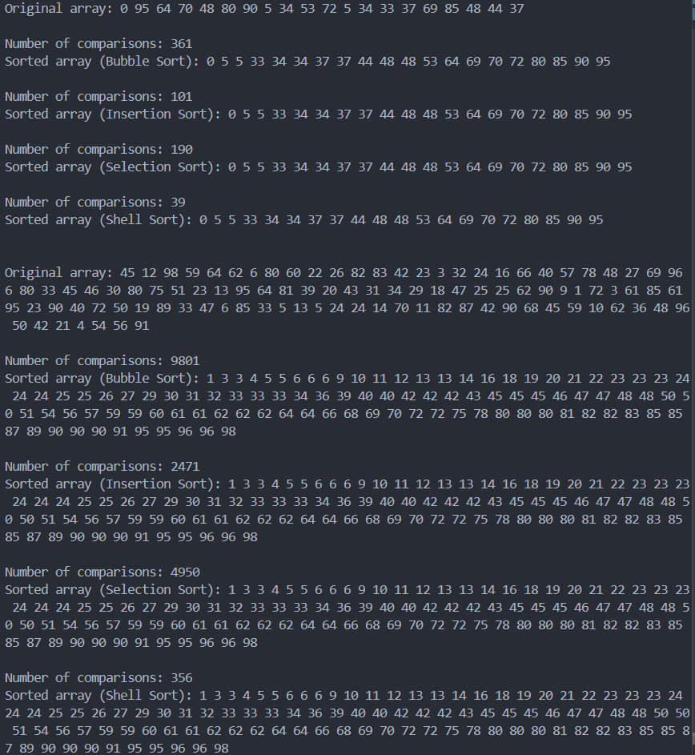

TASK 5
#include <iostream>
using namespace std;

void insertionSort(int arr[], int n) {
for (int i = 1; i < n; i++) {
int key = arr[i];
int j = i - 1;
while (j >= 0 && arr[j] > key) {
arr[j + 1] = arr[j];
j--;
}
arr[j + 1] = key;
}
}

int main() {
int arr[] = {9, 5, 1, 4, 3, 14, 119};
int n = sizeof(arr) / sizeof(arr[0]);

cout << "Original array: ";
for (int i = 0; i < n; i++) {
cout << arr[i] << " ";
}

insertionSort(arr, n);
cout << "\nSorted array: ";
for (int i = 0; i < n; i++) {
cout << arr[i] << " ";
}

return 0;
}
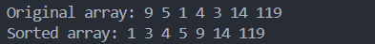

TASK 6
#include <iostream>
using namespace std;

void shellSort(int arr[], int n) {
for (int gap = n / 2; gap > 0; gap /= 2) {
for (int i = gap; i < n; i++) {
int temp = arr[i];
int j;
for (j = i; j >= gap && arr[j - gap] > temp; j -= gap) {
arr[j] = arr[j - gap];
};
arr[j] = temp;
}
}
}

int main() {
int size;
cout << "Enter size of array: ";
cin >> size;
int* arr = new int[size];
cout << "Enter elements of array! \n";
for (int i = 0; i < size; i++) {
cout << "Element " << i + 1 << ": ";
cin >> arr[i];
}

shellSort(arr, size);

cout << "Sorted array: ";
for (int i = 0; i < size; i++) {
cout << arr[i] << " ";
}

delete[] arr;
return 0;
}
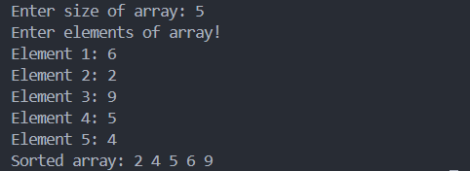
TASK 7
#include <iostream>
using namespace std;

void combSort(int arr[], int n) {
float shrink = 1.3;
int gap = n;
bool swapped = true;

while (gap > 1 || swapped) {
gap = (int)gap / shrink;
if (gap < 1) gap = 1;
swapped = false;
for (int i = 0; i + gap < n; i++) {
if (arr[i] > arr[i + gap]) {
swap(arr[i], arr[i + gap]);
swapped = true;
}
}
}
}

int main() {
int arr[] = { 2, 4, 5, 1, 6, 9, 7, 3, 8 };
int n = sizeof(arr) / sizeof(arr[0]);
cout << "Original array: ";
for (int i = 0; i < n; i++) {
cout << arr[i] << " ";
}
combSort(arr, n);
cout << "\nSorted array: ";
for (int i = 0; i < n; i++) {
cout << arr[i] << " ";
}
}

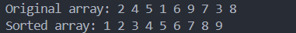

TASK 8
#include <iostream>
using namespace std;

int linearSearch(int arr[], int n, int target) {
for (int i = 0; i < n; i++) {
if (arr[i] == target) {
return i;
}
}
return -1;
}

int main() {
const int size = 10;
int arr[size];
for (int i = 0; i < size; i++) {
cout << "Enter element " << i + 1 << ": ";
cin >> arr[i];
}
int target = 5;

int result = linearSearch(arr, size, target);
if (result != -1) {
cout << "Element found at index: " << result << endl;
} else {
cout << "Element not found in the array." << endl;
}

return 0;
}

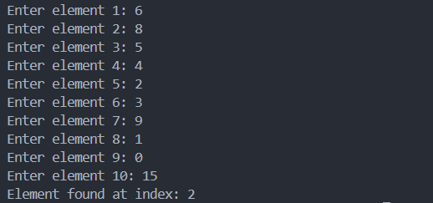
TASK 9
#include <iostream>
using namespace std;

void insertionSort(int arr[], int n) {
for (int i = 1; i < n; i++) {
int temp = arr[i];
int j = i - 1;
while (j >= 0 && arr[j] > temp) {
arr[j + 1] = arr[j];
j--;
}
arr[j + 1] = temp;
}
}
int interpolationSearch(int arr[], int size, int x) {
int low = 0, high = size - 1;

while (low <= high && x >= arr[low] && x <= arr[high]) {
if (low == high) {
if (arr[low] == x) return low;
return -1;
}
int pos = low + ((x - arr[low]) * (high - low)) / (arr[high] - arr[low]);

if (arr[pos] == x) return pos;
if (arr[pos] < x) low = pos + 1;
else high = pos - 1;
}
return -1;
}

int main() {
int arr[] = {10, 50, 30, 20, 40};
int size = sizeof(arr) / sizeof(arr[0]);
insertionSort(arr, size);
int x = 30;
int result = interpolationSearch(arr, size, x);
if (result != -1)
cout << "Element found at index: " << result << endl;
else
cout << "Element not found in array" << endl;
return 0;
}
TASK 10
#include <iostream>
using namespace std;

void shellSort(int arr[], int n) {
for (int gap = n / 2; gap > 0; gap /= 2) {
for (int i = gap; i < n; i++){
int temp = arr[i];
int j;
for (j = i; j >= gap && arr[j - gap] > temp; j -= gap) {
arr[j] = arr[j - gap];
}
arr[j] = temp;
}
}
}

int binarySearch(int arr[], int size, int key) {
int left = 0, right = size - 1;
while (left <= right) {
int mid = left + (right - left) / 2;
if (arr[mid] == key) {
return mid;
} else if (arr[mid] < key) {
left = mid + 1;
} else {
right = mid - 1;
}
}
return -1;
}

int main() {
int size;
cout << "Enter the number of elements: ";
cin >> size;
int* arr = new int[size];
cout << "Enter the elements:-\n";
for (int i = 0; i < size; i++) {
cout << "Element " << i + 1 << ": ";
cin >> arr[i];
}
shellSort(arr, size);
cout << "Sorted array: ";
for (int i = 0; i < size; i++) {
cout << arr[i] << " ";
}
cout << "\nEnter the element to search: ";
int key;
cin >> key;
int result = binarySearch(arr, size, key);
if (result != -1)
cout << "Element found at index: " << result << endl;
else
cout << "Element not found in array" << endl;

delete[] arr;
return 0;
}

